**TEAM NAME:** Team Seven

**DATE:** March 29, 2024

**SECTION:** 8

**INSTRUCTORS:** Profs.Semih Akin and Glen R. Gross

**TEAM MEMBERS:** Nathan Anthony, Fanta Cisse, Kismet Crossdale, Kamsi Dozie-Obele, Hayden Fuller, Jameson Giannattasio

**PROJECT NAME:** Motor Free Air Compressor

**TABLE 1: FUNCTIONAL CRITERIA\***

| **Subsystem** | **Team Member(s)** | **Subsystem** | **How it will be tested/demonstrated** | **Target Specification** | **Presentation Score (4 pt.)** | **Demo score based on target spec**  **(6 pt.)** | **TOTAL SCORE (10 pt.)** |
| --- | --- | --- | --- | --- | --- | --- | --- |
| A: Solar Chamber | 1 Nathan Anthony  2 Kamsi Dozie-Obele  3 Hayden Fuller | Description: A solar chamber (with inner and outer parts), and reflective coating made out of glass and plastic.  Function: store and increase air pressure through solar radiation and mechanical pressure build-up | Test:   * Test how low pressure affects chamber * Air Tightness | * Amount of pressure it can withstand (50 psi) [1], [Appendix] * Amount of temperature it can withstand (80 degrees Fahrenheit) [2] * Minimize the volume (2 gallon chamber) so pressure builds faster * 1 inch hole for pipe connection (to match pipe diameter) |  |  |  |
| B: Pipe: Pressure sensor, safety valve | 1 Fanta Cisse  2 Kismet Crossdale  3 Kamsi Dozie-Obele | Description: A steel pipe (1’’ x 1’’) that has 5 total inputs (pressure sensor, temperature sensor, a safety valve, a shut-off valve, and an air valve)  Function: to measure temperature and pressure, ensuring that the product is safe for the user; confirming that the air compressor is actually working | Test:   * Pipe able to hold air pressure traveling from chamber * Test readings of sensors (pressure) * Pipe and connections are airtight | * Pipe dimensions:   + 1” diameter   + 8” length * Withstand pressure (50 psi) and high heat (Ideal maximum temperature in region, 80 degrees Fahrenheit [2]) * Sensors + Safety valve need to be easily insertable * Inserting holes should be airtight * Sensors correctly reading values with accuracy |  |  |  |
| C: Valve to connect air hose and pump | 1 Kismet Crossdale  2 Hayden Fuller  3 Jameson Giannattasio | Description: An air pump/gun connected to a 25’ long hose, which would then be attached to subsystem 2.  Function: Interface with user to allow input and output of pressure; Way to detach pump and air hose without losing air pressure. | Test:   * How much air is being distributed * If air flow is being controlled * Pump and nozzle connection is airtight * How nozzle size affects output pressure | * ¼ inch * Lever to open air compressor, letting air escape to nozzle * Hose can handle pressurized air output * Psi is effective to clean surface * Nozzle blow at a rate of 30m/s * Pump can supply 50psi without air loss |  |  |  |
|  |  |  |  |  |  | **Average Score** |  |

**TABLE 2: SUBSYSTEM INTEGRATION TEAM**

| **Team Members** | **Subsystem Integration Table (2 pt.)** | **Planning**  **(2 pt.)** | **Integration Standards**  **(2 pt.)** | **MS5 proposed system demo.**  **(2 pt.)** | **Avg. score from Table 1**  **(norm. to 2 pt.)** | **TOTAL SCORE**  **(10 pt.)** |
| --- | --- | --- | --- | --- | --- | --- |
| **1 Fanta Cisse**  **2 Nathan Anthony**  **3 Jameson Giannattasio** |  |  |  |  |  |  |

**TABLE 3: SUBTEAM GRADES FROM TABLES 1 & 2**

| **Team Members** | **Subsystem A**  **(10 pt.)** | **Subsystem B**  **(10 pt.)** | **Subsystem C**  **(10 pt.)** | **Subsystem D**  **(10 pt.)** | **SIT**  **(10 pt.)** | **AVERAGE SCORE**  **(10 pt.)** |
| --- | --- | --- | --- | --- | --- | --- |
| **1 Nathan Anthony** |  |  |  |  |  |  |
| **2 Fanta Cisse** |  |  |  |  |  |  |
| **3 Kismet Crossdale** |  |  |  |  |  |  |
| **4 Kamsi Dozie-Obele** |  |  |  |  |  |  |
| **5 Hayden Fuller** |  |  |  |  |  |  |
| **6 Jameson Giannattasio** |  |  |  |  |  |  |

**SUBSYSTEM 1 Diagram:**

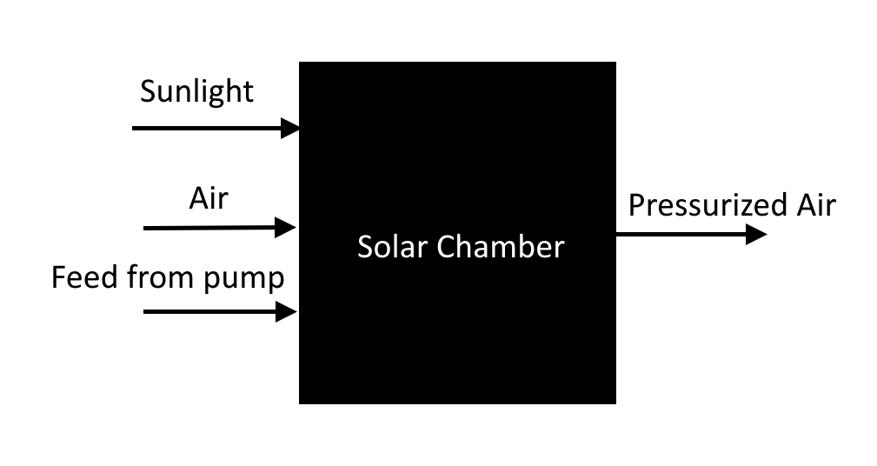

**SUBSYSTEM 2 Diagram:**

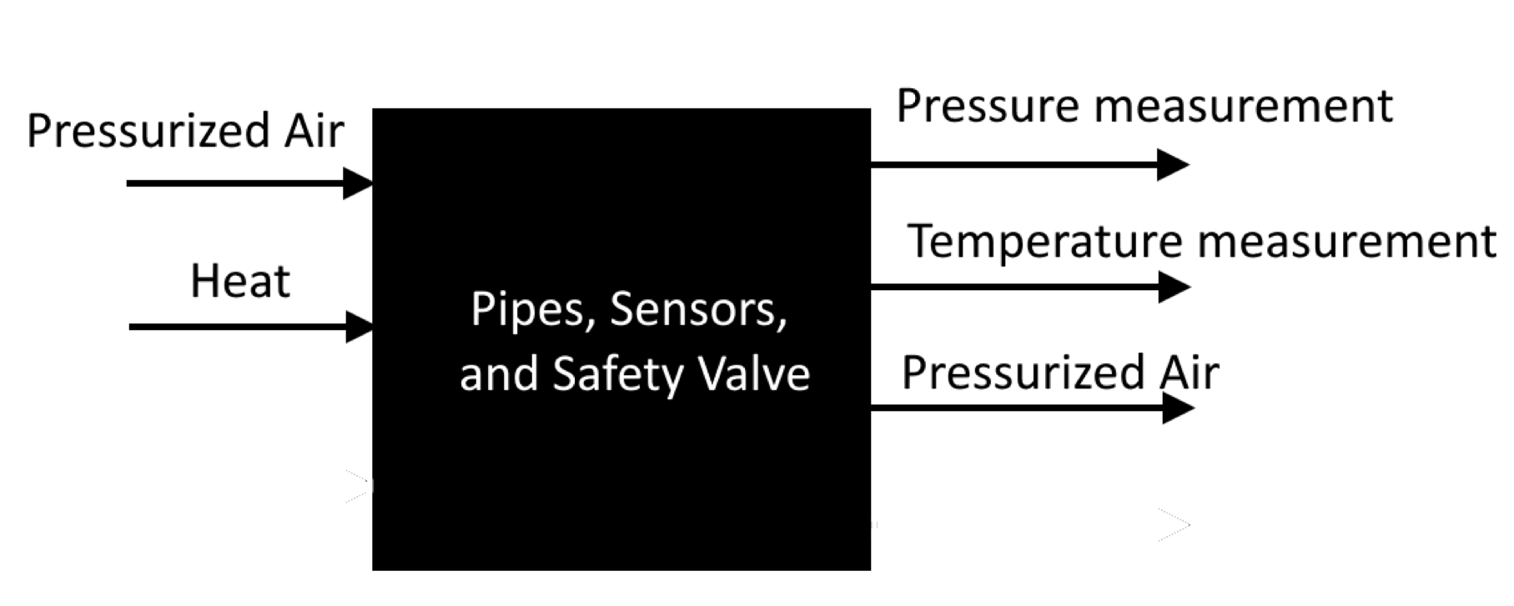

**SUBSYSTEM 3 Diagram:**

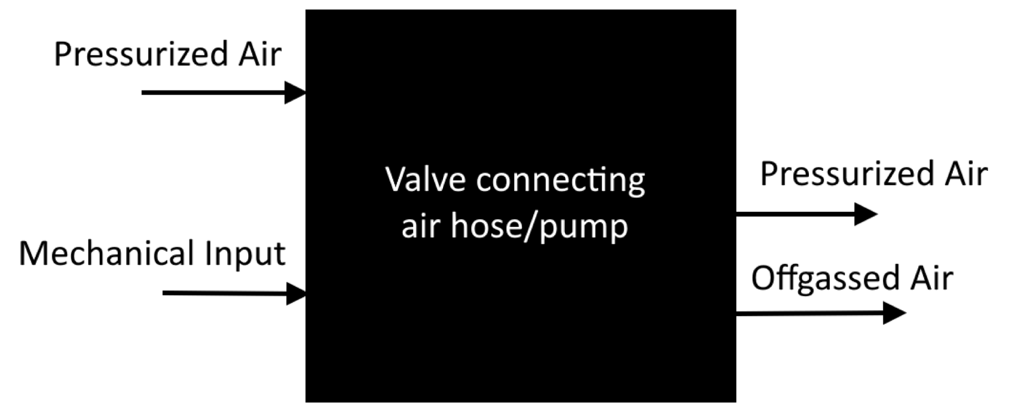

**SIT Diagram:**

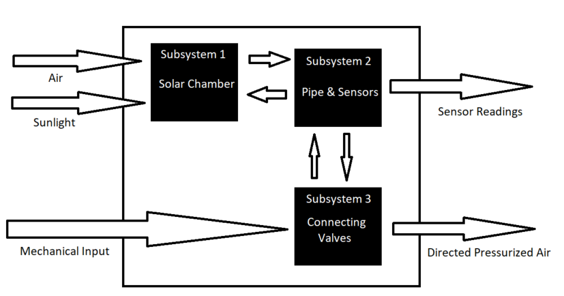

**MATERIALS LIST (Full excel sheet in Appendix):**

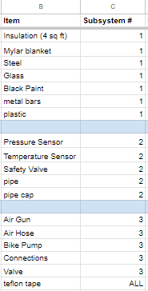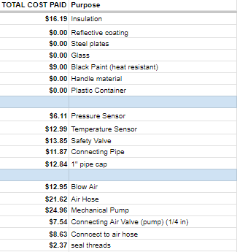

*Steel has been changed due to safety constraints*

**SIT SUMMARY:**

Our subsystem 1, titled the solar chamber, is our main system that the other two subsystems depend on the functionality of. This chamber will hold most of our air that is going to be compressed from the solar radiation as well as an initial buildup of pressure from subsystem 3. Subsystem 2 is a steel pipe that connects the first and third subsystem which allows us to measure pressure as well as connect valves to it. The third subsystem is our valves, pump, and nozzle that allow us to pressurize the container and release the air in a direction with the nozzle. This subsystem directly connects to the second subsystem, allowing the air to be pressurized from the pumps connection as well as releasing the compressed air with the nozzles connection.

In order to create a cohesive single product, we have to make sure each subsystem smoothly fits together without problems. The plan is to first drill holes into the pipe and attach the different sensors and valves to it by threading the created holes. Next, our group connects the outfitted pipe to the solar chamber (we will screw it into the side of the chamber). We must make sure that the hole that allows the connection to the solar chamber is correctly sized to ensure no air is leaked between the first and second subsystem. After that is completed, our group will then screw the air hose into the shut-off valve (which is attached to the pipe) so that the air could travel from the chamber to the hose and nozzle without losing pressure due to an airtight connection which has to be enforced. We would then connect an air pump to the pipe using the connections created earleir so the user could pump the air into the pipe and solar chamber to build pressure. Subsystem teams will meet and create their parts at the same times to assure that the connections being made will work well together while maintaining functionality across the product.

Some issues that we might face while trying to combine the subsystems into one system are some parts breaking, parts not fitting, and the entire device not being able to work. We currently only have one of each part, so if something breaks (such as the pipe) it would set us back. From this, we have learned to buy extras of each part if we believe there is a chance of malfunction. If parts do not fit, we must adjust our design measurements to adhere to these complications because, as stated previously, we do not have extra parts. There is also the chance that subsystems may work independently but are inoperative as a final cohesive design. If the entire product does not work as intended for Milestone 4, we will try to adjust and innovate our design for Milestones 5 and 6 to exact better results. If we experience these aforementioned setbacks in their entirety, we will be in danger of falling behind for Milestone 5.

**Citations**

[1] “Packaging – internal pressure resistance - Campden BRI.” [Online]. Available: <https://www.campdenbri.co.uk/videos/packaging-pressure-video.php#:~:text=Pressures%20for%20plastic%20containers%20will,usually%20exceeding%20around%2016%20bar>.

[2] “Nigeria - Climatology.” [Online}. Available: <https://climateknowledgeportal.worldbank.org/country/nigeria/climate-data-historical#:~:text=Mean%20annual%20temperature%20for%20Nigeria,annual%20precipitation%20is%201%2C165.0%20mm>.

**Appendix**

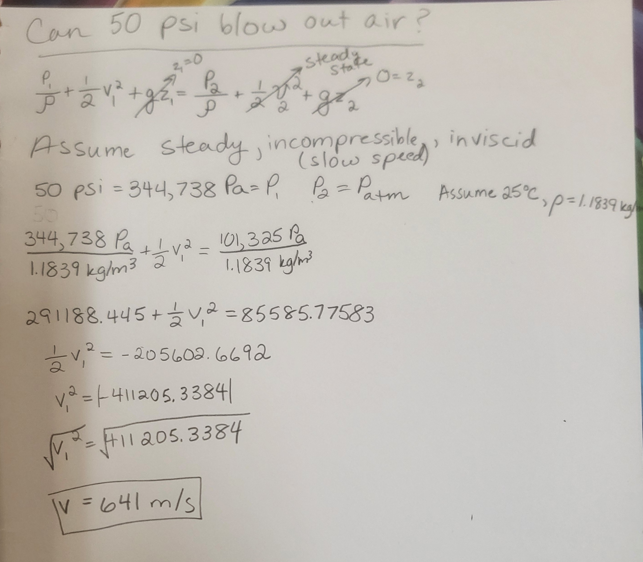

Calculations to prove that 50 psi (safe margin) will work in our device

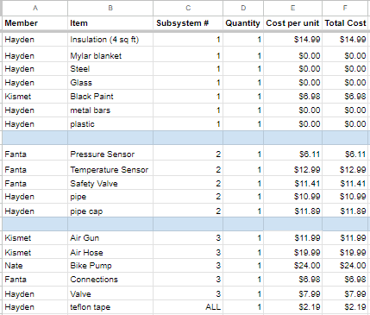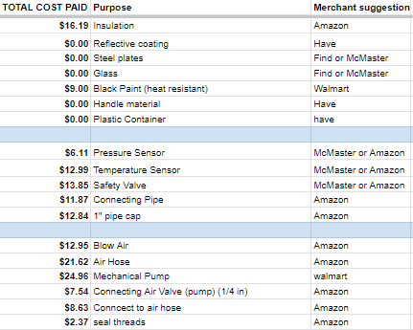

Parts 1 and 2 of material list excel sheet

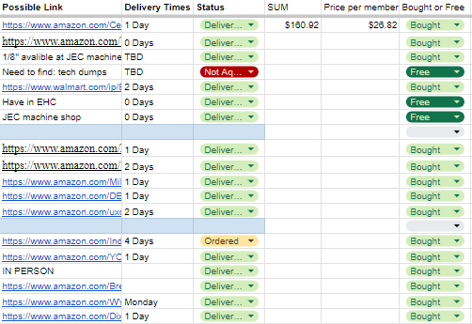

Part 3 of material list excel sheet